# Brainstorm

**TIP**

You can select a sticky note and hit the pencil [switch to sketch] icon to start drawing!

## Before you collaborate

A little bit of preparation goes a long way with this session. Here’s what you need to do to get going.

10 minutes

**1**

## Define your problem statement

What problem are you trying to solve? Frame your problem as a How Might We statement. This will be the focus of your brainstorm.

5 minutes

**2**

## Brainstorm

Write down any ideas that come to mind that address your problem statement.

10 minutes

**3**

## Group ideas

Take turns sharing your ideas while clustering similar or related notes as you go. Once all sticky notes have been grouped, give each cluster a sentence-like label. If a cluster is bigger than six sticky notes, try and see if you and break it up into smaller sub-groups.

20 minutes

**4**

## Prioritize

Your team should all be on the same page about what's important moving forward. Place your ideas on this grid to determine which ideas are important and which are feasible.

20 minutes

## After you collaborate

You can export the mural as an image or pdf to share with members of your company who might find it helpful.

**Quick add-ons**

# & idea prioritization

### Use this template in your own brainstorming sessions so your team can unleash their imagination and start shaping concepts even if you're not sitting in the same room.

1. **Team gathering**

Define who should participate in the session and send an invite. Share relevant information or pre-work ahead.

1. **Set the goal**

Think about the problem you'll be focusing on solving in the brainstorming session.

**Learn how to use the facilitation tools**

## PROBLEM

Many businesses use their own method to keep track of their inc ome and spending because they believe this to be the most impo rtant factor in how well their operations are doing.

It is a healthy habit to keep track of daily spending and income, b ut because individuals are ignorant of the correct apps to protect their privacy and lack the capacity to make decisions, they are stil

supports all forms of money, including cryptocurrency

Good and userfriendly UI to provide features in a great representation

View spending in real-time and issue notifications.

**Rajeshkumar S**

To have a financially solid existence, balance all debt and earnings.

**Ramachandramoorthy K B**

Alerts regarding unreported spending and ways to save money

**Ramya S**

To increase the number of app users, connect all different sorts of banks globally.

**Umapathi K**

leveraging IBM applications to deliver high- quality and performant applications

Attractive Dashboard

Sorting costs according to their significance

#### User Interface

Light and Dark Mode

###### View

Alerts regarding unreported spending and ways to save money

Good and

1. **Share the mural**

**Share a view link** to the mural with stakeholders to keep them in the loop about the outcomes of the session.

1. **Export the mural**

Export a copy of the mural as a PNG or PDF to attach to emails, include in slides, or save in your drive.

**10 minutes** to prepare

**1 hour** to collaborate

**2-8 people** recommended

Plan appropriately based on anticipated costs and requirements

Graphical dashboards to provide a clear view and understanding of personal expenses

High-level privacy protection and credential security

Link all bank and UPI accounts to keep track of spending

**C**

Use the Facilitation Superpowers to run a happy and productive session.

Link all bank and UPI accounts to keep track of spending

[**Open article**](https://support.mural.co/en/articles/2113740-facilitation-superpowers)

l utilising the old-fashioned note-taking techniques to do so.

##### Key rules of brainstorming

To run an smooth and productive session

Friendly Animation and Design

All transactions and information

Hosting and deploying the

###### spending in

real-time and issue notifications.

Sorting costs according to their significance

userfriendly UI

to provide features in a great representation

High-level privacy protection and credential

##### Keep moving forward

To increase the number of app users, connect all different sorts of banks globally.

**Strategy blueprint**

Define the components of a new idea or strategy.

[**Open the template**](https://app.mural.co/template/e95f612a-f72a-4772-bc48-545aaa04e0c9/984865a6-0a96-4472-a48d-47639307b3ca)

**Customer experience journey map**

Stay in topic. Defer judgment.

Encourage wild ideas. Listen to others.

transfers must be encrypted.

#### Security

application on the IBM Cloud

##### Importance

leveraging IBM applications to deliver high- quality and performant applications

If each of these

security

Understand customer needs, motivations, and

obstacles for an experience.

[**Open the template**](https://app.mural.co/template/b7114010-3a67-4d63-a51d-6f2cedc9633f/c1b465ab-57af-4624-8faf-ebb312edc0eb)

Go for volume. If possible, be visual.

tasks could get

done without any difficulty or cost, which would have the most positive impact?

Login using their personal account's

**Strengths, weaknesses, opportunities & threats**

Identify strengths, weaknesses, opportunities, and threats (SWOT) to develop a plan.

Plan appropriately based on anticipated costs and requirements

Graphical dashboards to provide a clear view and understanding of personal expenses

To have a financially solid existence, balance all debt and earnings.

[**Open the template**](https://app.mural.co/template/6a062671-89ee-4b76-9409-2603d8b098be/ca270343-1d54-4952-9d8c-fbc303ffd0f2)

[**Share template feedback**](https://muralco.typeform.com/to/CiqaHVat?typeform-source=app.mural.co)

Adding the Expense Detials

### Personal Expense Tracker

Adding the income Detials

supports all forms of money, including cryptocurrency

Alerting the person if expence is over

[**Share template feedback**](https://muralco.typeform.com/to/CiqaHVat?typeform-source=app.mural.co)

##### Feasibility

Regardless of their importance, which tasks are more feasible than others? (Cost, time, effort, complexity, etc.)

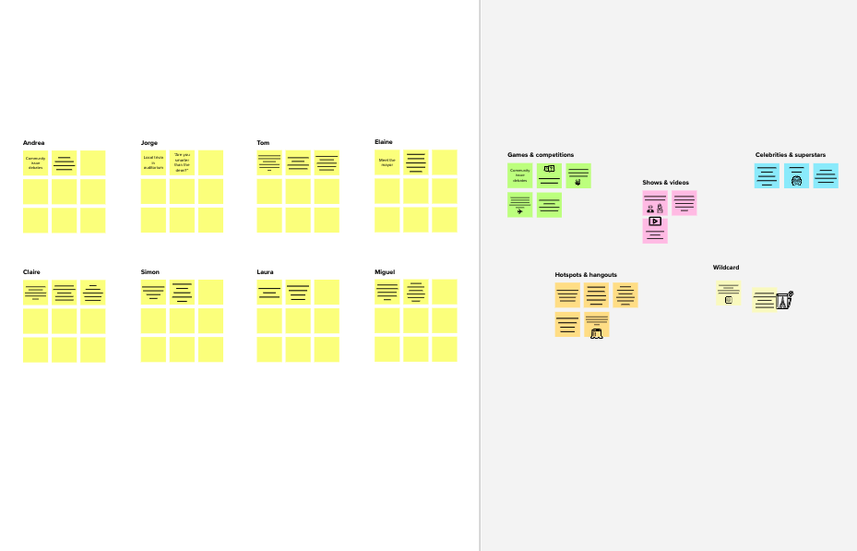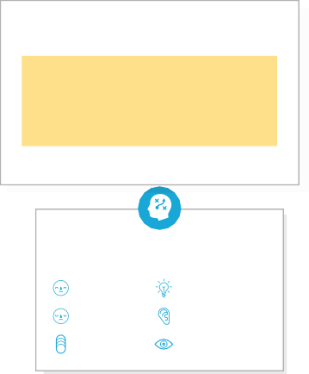

**Template**

**Need some inspiration?**

See a finished version of this template to kickstart your work.

[**Open example**](https://app.mural.co/template/e5a93b7b-49f2-48c9-afd7-a635d860eba6/93f1b98d-b2d2-4695-8e85-7e9c0d2fd9b9)